1.

-frontEnd

-FileService

-SessionService

-SessionFunctionService

-APIGateway

-MemberService

-BoardService

-EurekaDiscoveryService

상기한 브랜치를 클론하고, ec2위에 jenkins와 docker를 활용해 빌드.

빌드에 필요한 docekrfile은 exec 파일에 dockerfiles 폴더에 정리해놨음.

각 dockerfile을 /test/<서비스명>으로 만들어지는 ec2 디렉토리에 저장하고 빌드.

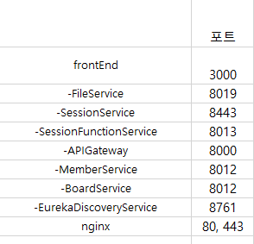

각 서비스별 포트는 다음과 같음.

Ec2에 docker 설치 후 Jenkins를 도커로 설치. 그 후 상기한 모든 서비스를 docker를 활용해 설치함. Nginx conf는 다음과 같음.

user nginx;

worker_processes 1;

error_log /var/log/nginx/error.log warn;

pid /var/run/nginx.pid;

events {

worker_connections 1024;

}

http {

upstream FrontServer{

server 172.17.0.1:3000;

keepalive 32;

}

server {

listen 80;

listen [::]:80;

server_name i8a703.p.ssafy.io;

location /{

proxy_pass http://FrontServer/;

}

location ^~/.well-known/acme-challenge/ {

default_type "text/plain";

root /var/www/cossafyco;

}

}

server {

listen 443 ssl;

server_name ssafy.cossafyco.kro.kr;

#access_log /var/log/nginx/proxy/access.log;

#error_log /var/log/nginx/proxy/error.log;

ssl_certificate fullchain.pem;

ssl_certificate_key privkey.pem;

location / {

proxy_pass http://FrontServer/;

}

location /api{

rewrite ^/api(.*)$ $1 break;

proxy_pass http://172.17.0.1:8000;

}

location /session {

rewrite ^/session(.*)$ $1 break;

proxy_pass https://172.17.0.1:8443;

}

location /ab {

rewrite ^/ab(.*)$ $1 break;

proxy_pass http://172.17.0.1:8011;

}

}

include /etc/nginx/mime.types;

default_type application/octet-stream;

log_format main '$remote_addr - $remote_user [$time_local] "$request" '

'$status $body_bytes_sent "$http_referer" '

'"$http_user_agent" "$http_x_forwarded_for"';

access_log /var/log/nginx/access.log main;

sendfile on;

#tcp_nopush on;

keepalive_timeout 65;

#gzip on;

include /etc/nginx/conf.d/*.conf;

#security

server_tokens off;